Our visit to the Effigy Mounds.

This past Sunday, May 1, about fifty people spent the afternoon learning from Larry Johns about the effigy mounds in general and especially about the mound group located Mendota Mental Health on the north shore of Lake Mendota. It was a cold and windy day, more like March than the first day of May, but spirits were high and there were many people outside of Grace in attendance.

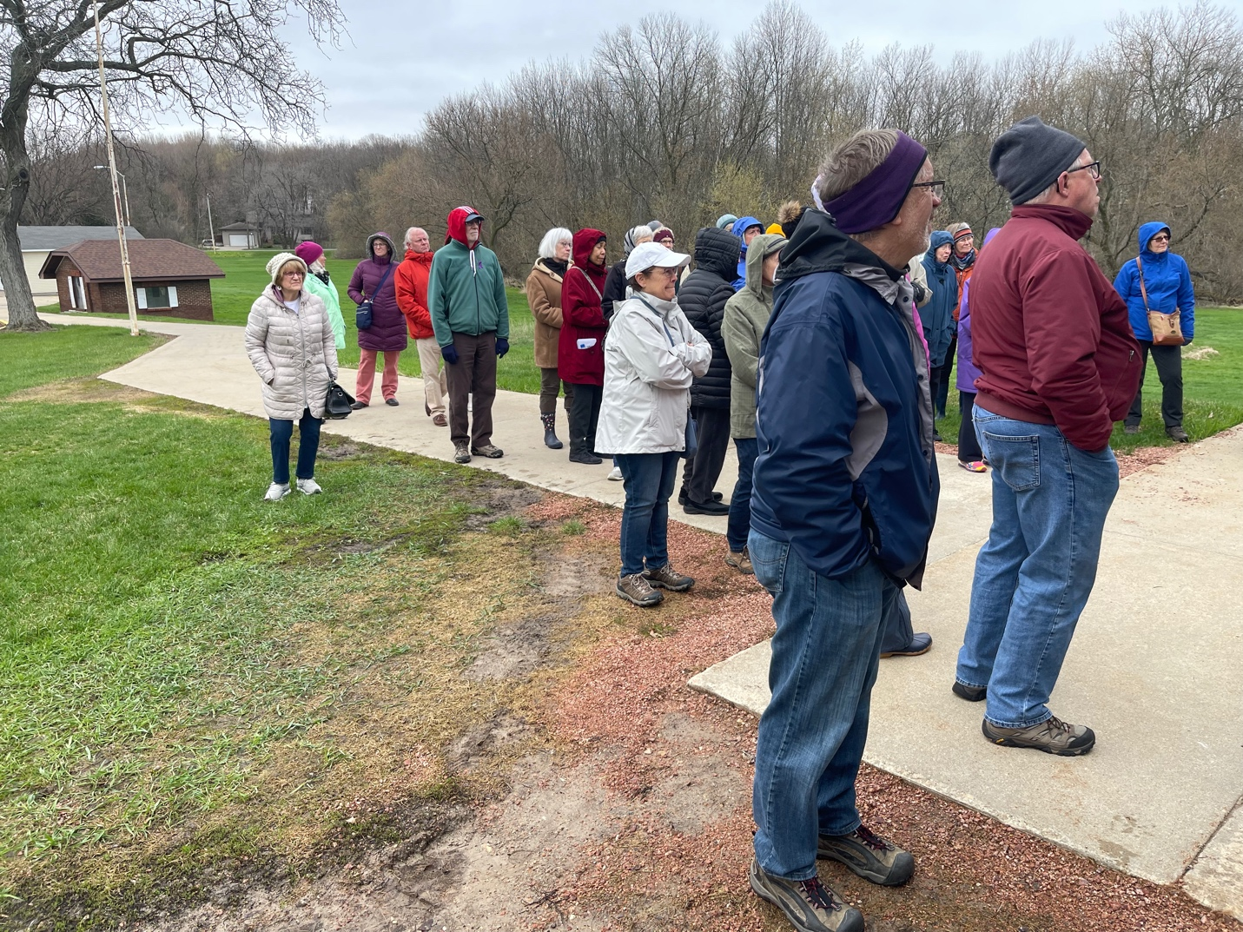

Larry is a member of the Oneida nation whose interest in and knowledge of the mounds goes back decades. He worked for several years for Dane County on a project trying to map all of the mounds in the County and has also explored and mapped mounds outside of Dane County. The mounds date from There is considerable uncertainty about the purpose and meaning of the mounds, although the mounds located in and around Madison were used for burials. They were constructed between around 600 ce and 1200 ce by the Woodland Peoples and they are sacred places for the Ho-Chunk who have called this area home for centuries

Many of them were destroyed by white settlers, farmers, and archaeologists in the 19th and 20th centuries. Larry told a poignant story about the destruction of a mound by a local property owner just a few days before the state law protecting them went into effect in the 1980s, so that he could build a house on the property. Larry received the human remains found in that mound and reburied them. The mounds on the grounds of MMHI suffer from the effects of mowing that destroys the edges of the mounds.

Originally, there were around 50 mounds on the site that now is occupied by MMHI. One group has been completely destroyed. Most notably, however, an eagle effigy that is the largest eagle mound in existence remains largely intact. It has a wingspan of 624 feet and a body length of 131 ft.

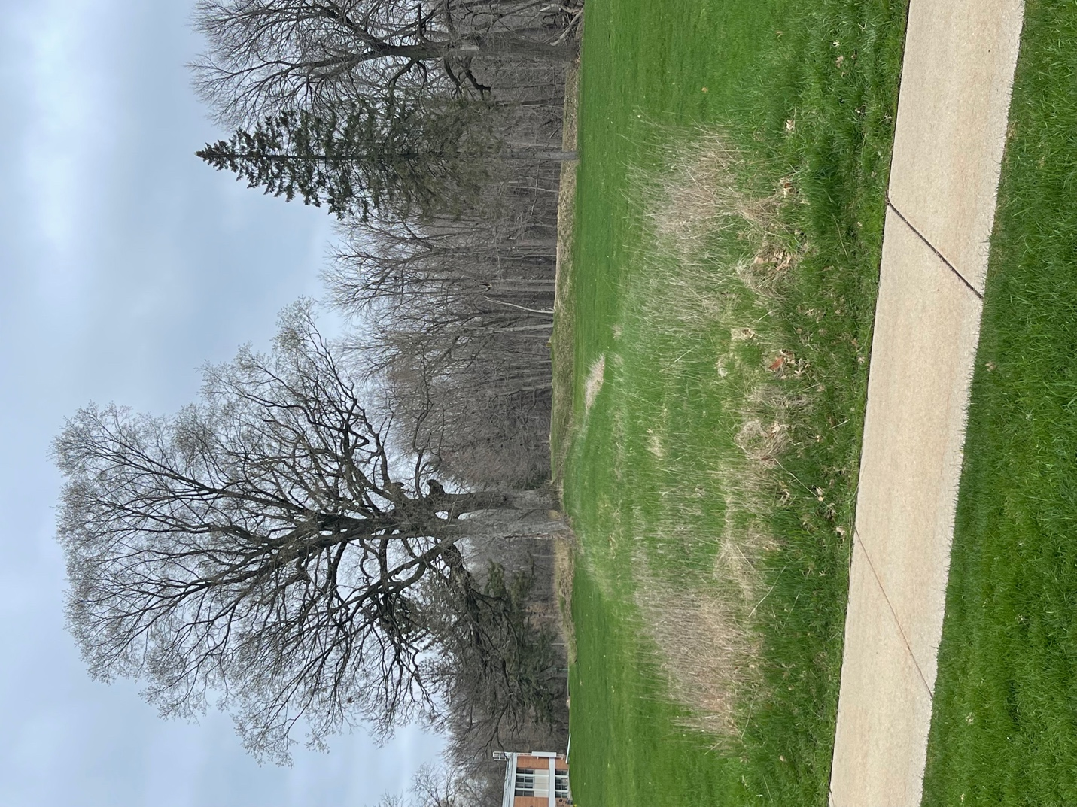

The photo above shows one of the wings of the Eagle Mound.

The mounds are open to the public, located near a parking lot at the intersection of Muir Dr. and Harper Rd. in Madison.

While the scheduled events in the Owning our Past series have concluded, we are still working on rescheduling the session with Ada Deer that had to be postponed due to illness. There is also interest in further events including arranging for attendance at the 200th anniversary celebration of the Wisconsin Oneida at Holy Apostles Church in October.

